ALESSANDRO MERELLA
ATTORNEY

ABOUT ME
Though naturally calm, I am an inherently dynamic extrovert who always keeps an open mind and remains honest and fair.
I enjoy carrying out responsibilities, highly value commitment, respect for professional ethics, and strive for a job well done.
I have a passion for cinema, a deep interest in social relationships, and enjoy reading and traveling. I am also open to any kind of new experience.

SKILLS
Regulatory, banking and financial law; Compliance, including AML; Private Equity; Commercial law.
Excellent communication and organizational skills, versatile, highly adaptable, with a creative and original approach to problem solving, and comfortable in any social situation.

PROFESSIONAL EXPERIENCE
February 2021 - present: Secondments with Ethikos
Long-term secondments (18 months to 4+ years) within major Belgian financial institutions active in (a.o.) the banking and private equity sectors: regulatory matters, governance, outsourcing, GDPR, general support, etc.

December 2020 - present: Ethikos, Brussels
Attorney: extensive experience in regulatory watch and regulatory matters, legal opinions, contractual documents and procedural acts in various areas, including financial law, private equity, compliance (including AML) and commercial law.
June 2017 - November 2017: La Boiserie SA (wood products), Waudrez
Polyvalent employee: general and specialized salesman, in charge of the home supply department, cashier, in charge of orders and stock file management, customer adviser.

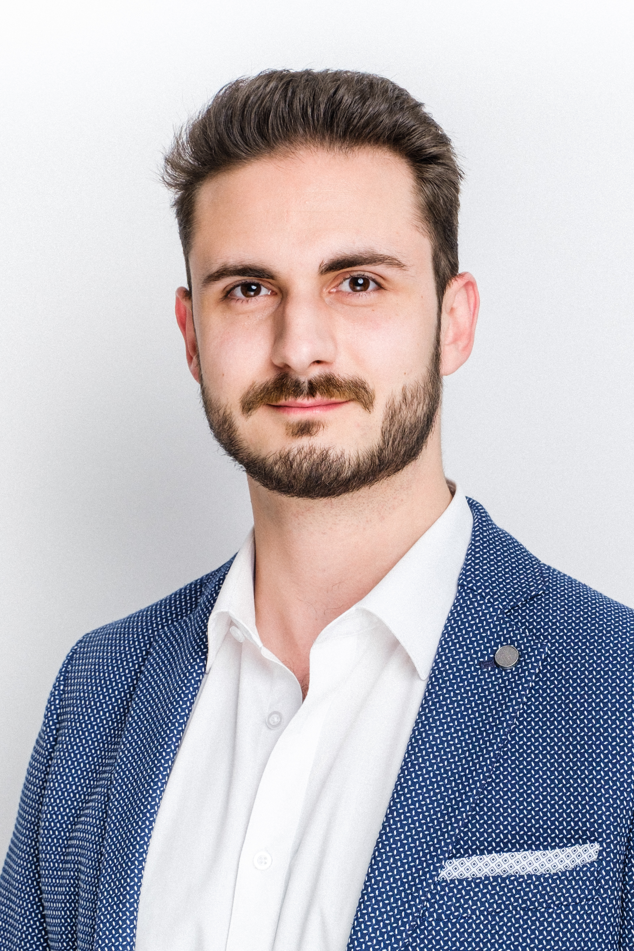

February 2017 - March 2017: Anny Lhoir and Sophie Kebers - Associate notaries, Jemappes
Executive secretary: direct intermediary, assistant, in charge of schedules, appointments, liaison and client reception.
2009 - 2016: Pile ou Face (clothing store), Saint-Ghislain
Commercial experience: unpacking, shelving, labeling, storage and sales, customer advises, stock files management.

EDUCATION
2018 - 2020: Master's degree in Law - economic and social law - ULB - Brussels, magna cum laude
Master's thesis: “Les apports en industrie sous l'empire du Code des sociétés et des associations : les conséquences de la réforme sur la société à responsabilité limitée (SRL)”.
2010 - 2018: Bachelor's degree in Law
ULB - Mons.

LANGUAGES
French: C2 - native.
English: C1 - full professional proficiency.
Italian: C1 - professional proficiency.
Dutch: B1 - working proficiency.

CONTACT
Phone: +32 (0) 478.77.60.62
E-mail: a.merella@ethikos.legal
Address: 66 Avenue Louise, 1050 Brussels
Date of birth: 25 December 1993

